Test Plan


H2O America
CM065 – Send Current Account Balance to Invoice Cloud

This work product/document is intended solely for the information and use of the management of H2O America and is not intended to be and should not be used by anyone other than these specified parties.

Author: EY
Creation Date: July 23, 2025
Last Updated: October 23, 2025
Version: 1.0

Document Control

Change Record

Date | Author | Version | Change Reference
2025-Jul-23 | Jayvee Gabriel | 0.1 | Initial Version
2025-Sep-08 | Jayvee Gabriel | 0.2 | Added testing scenario.
2025-Oct-21 | Jayvee Gabriel | 0.3 | Changed INTC012 to CM065. Created inbound web service and retested all scenarios.
2025-Oct-23 | Alyssa Go | 1.0 | Passed review. Baselined version.

Reviewers

Name | Position

Distribution

Copy No. | Name | Location
Note to Holders:
If you receive an electronic copy of this document and print it out, please write your name on the equivalent of the cover page, for document control purposes.
If you receive a hard copy of this document, please write your name on the front cover, for document control purposes.

Approved By

Name | Title | Signature | Date

Related Documents

Version # | Related Documents | Release Date
0.1 | H2O - CCS TD - INTC012 - Data Refresh Service.docx | 2025-Jul-14

Table of Contents
1 Document Control 2
1.1 Change Record 2
1.2 Reviewers 2
1.3 Distribution 2
1.4 Approved By 2
1.5 Related Documents 2
2 Overview 5
2.1 Business Requirement 5
2.2 System Changes 5
2.3 Scope 5
3 Assumptions 5
4 Test Method 5
5 Validation Technique 5
6 Data Set Up 6
6.1 Configuration Data 6
6.1.1 Script 6
6.1.1.1 CM_GetCurBal 6
6.2 Transaction Data 7
6.2.1 Account 7
7 Test Plan 8
7.1 Test Conditions and Expected Results 8
7.2 Execution Steps 8
7.3 Warning/Error Messages 9
8 Actual Results 10
8.1 CONDITION 1 – Account ID is not valid 10
8.1.1 Test Data 10
8.1.2 Result 10
8.2 CONDITION 2 – Feature Configuration is not configured. 12
8.2.1 Configuration Data 12
8.2.2 Test Data 12
8.2.3 Result 12
8.3 CONDITION 3 – Data Refresh To Do Type is not configured in Feature Configuration. 13
8.3.1 Configuration Data 13
8.3.2 Test Data 13
8.3.3 Result 13
8.4 CONDITION 4 – Data Refresh To Do Type from the Feature Configuration is invalid. 15
8.4.1 Configuration Data 15
8.4.2 Test Data 15
8.4.3 Result 15
8.5 CONDITION 5 – Account ID is valid. 17
8.5.1 Configuration Data 17
8.5.2 Test Data 17
8.5.3 Result 17
9 Open Issues 18

Overview
This document defines the approach for the testing that will be performed to validate that the requirements of CM065 have been met.

Business Requirement
CM065 is designed to return person and bill information values related to Account used as input when the service is invoked.

System Changes
A new service script is developed that will accept the account ID as input and the following fields as output:
- Person ID
- Person Name
- Current Amount Balance
- Total Amount Balance
- Block CC (Defaulted to N)
- Block ACH (Defaulted to N)
- Status (OK or F)
- Status Message

Scope
The scope of CM065 includes the creation of the schema and the service script. The trigger of the service script is not within the scope of this design.

Assumptions
- Required configurations such as Feature Configuration, To Do Type, and Messages used are already configured within the system.

Test Method
To test the components, the “Try It Out” function on the API specification of the Inbound Web Service page will be used to trigger the logic.

Validation Technique
Once the service script is invoked, the output can be validated by checking if the output fields are populated. For scenarios where a To Do Entry is expected, the To Do Entry can be checked on the To Do Entry page. An email will be sent for some scenarios.

Data Set Up

Configuration Data

Script

CM_GetCurBal
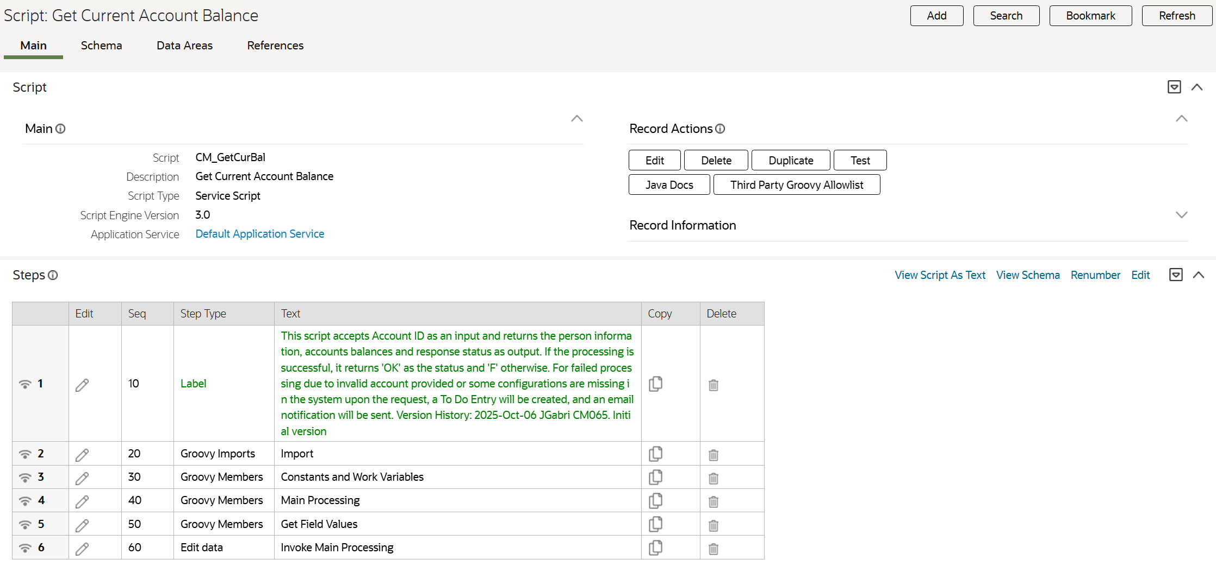

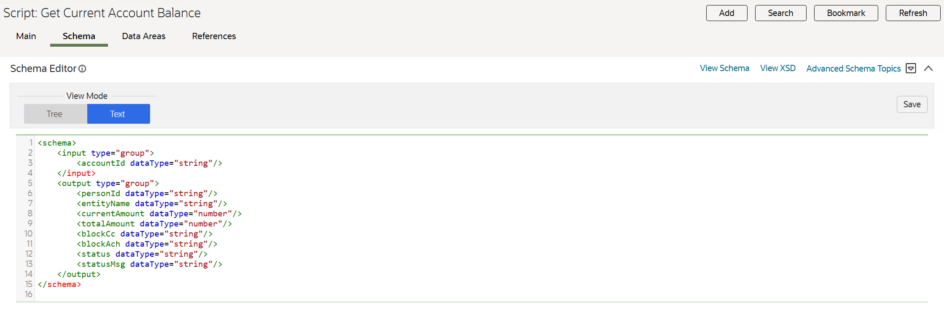
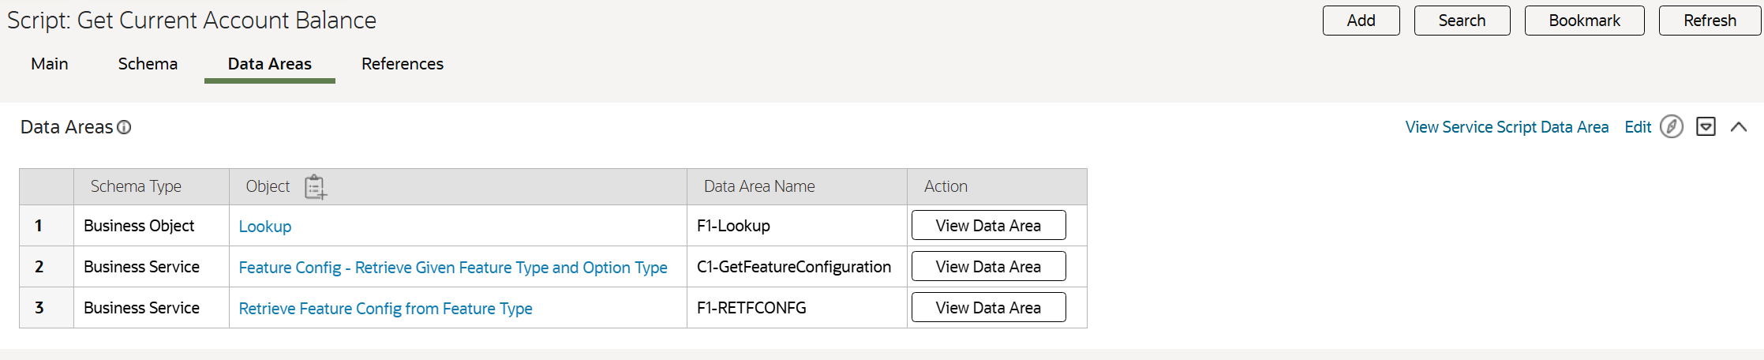

Inbound Web Service

CM-InvoiceCloudWebService
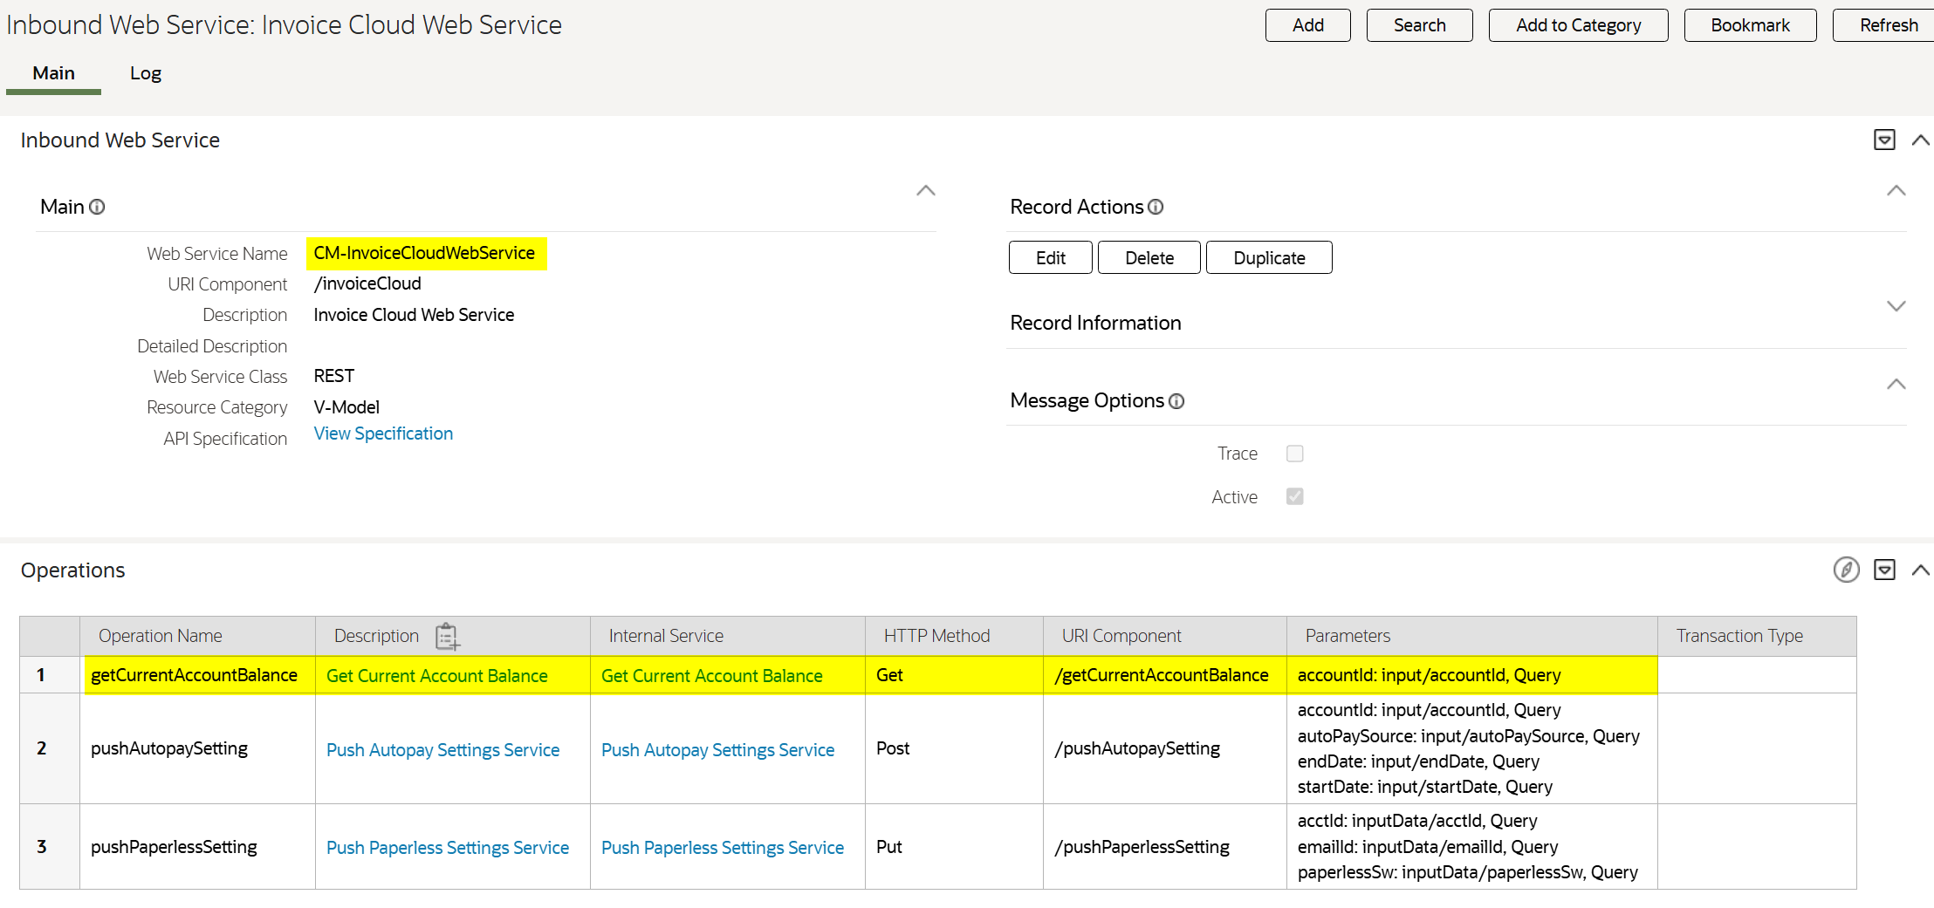

Transaction Data

Account
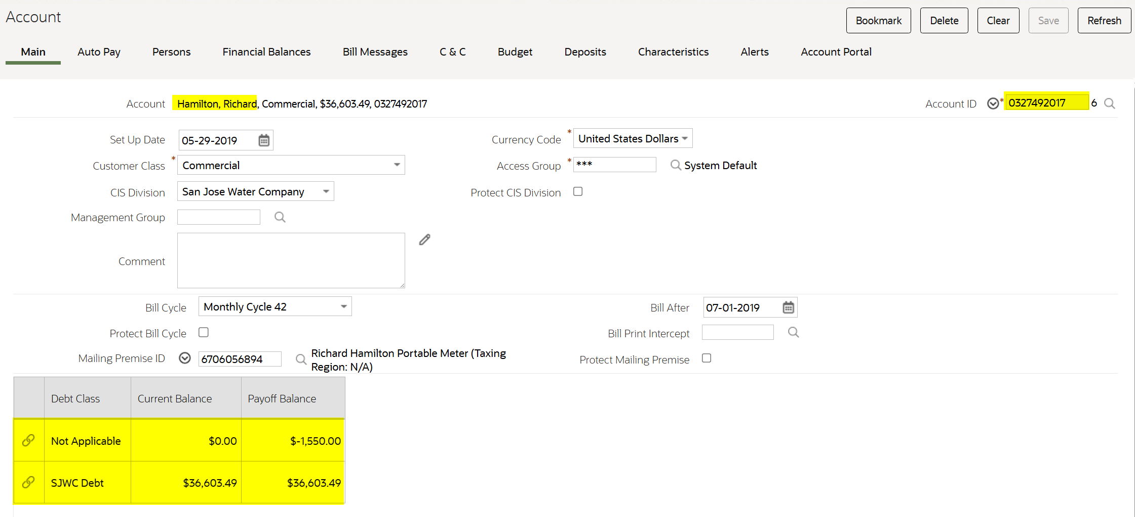

Test Plan

Test Conditions and Expected Results
SeqNbr | Test Condition Description | Expected Result | Priority |  | Passed (Y or N)
If a condition did not pass, include reference to Actual Results section.
1 | Account ID is not valid. | Status will be “F” and status message will have the error message.  A To Do Entry will be created.  An email will be sent. |  | 10 | Y
2 | Feature Configuration is not configured. | Status will be “F” and status message will have the error message. |  | 10 | Y
3. | Data Refresh To Do Type is not configured in Feature Configuration. | Status will be “F” and status message will have the error message.  An email will be sent. |  | 10 | Y
4. | Data Refresh To Do Type from the Feature Configuration is invalid. | Status will be “F” and status message will have the error message.  An email will be sent. |  | 10 | Y
5. | Account ID is valid. | All the fields will be populated.  Status will be “OK” and status message will be “Transaction successful”. |  | 10 | Y

Execution Steps
Step | Description | Test Conditions covered
1.0 | Navigate to the Inbound Web Service page for Invoice Cloud. | 1 to 5
2.0 | Add the authorization | 1 to 5
3.0 | Go to /getCurrentAccountBalance operation and click the Try It Out button. | 1 to 5
4.0 | Input Account ID and click execute. | 1 to 5
5.0 | Validate the output fields | 1 to 5
6.0 | Check the To Do Entry created | 1 to 5
7.0 | Check if there is an email sent. | 1 to 5

Warning/Error Messages
Message Category | Message Nbr | Error Message
90005 | 10101 | Feature Configuration for Feature Type %1 is missing.
90005 | 10103 | Feature Configuration %1 Option Type %2%3 is missing.
90005 | 10105 | Feature Configuration %1 Option Type %2%3 (%4) is not a valid %5.
90005 | 10106 | There is no existing Account Id %1.

Actual Results

CONDITION 1 – Account ID is not valid

Test Data
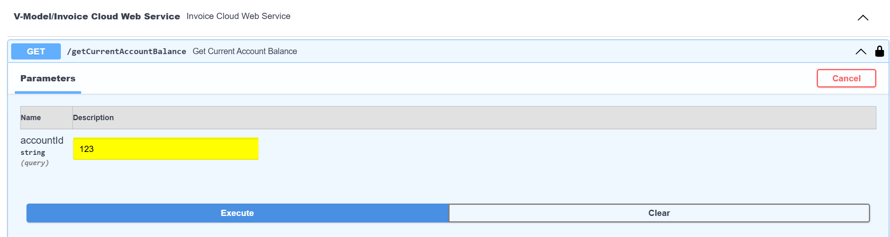
“123” is inputted as accountId.

Result
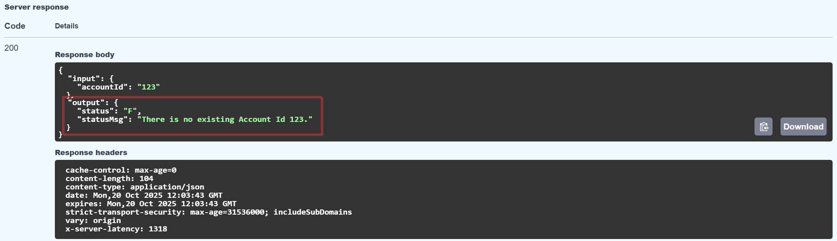

Status – F
Status Message - There is no existing Account Id 123.
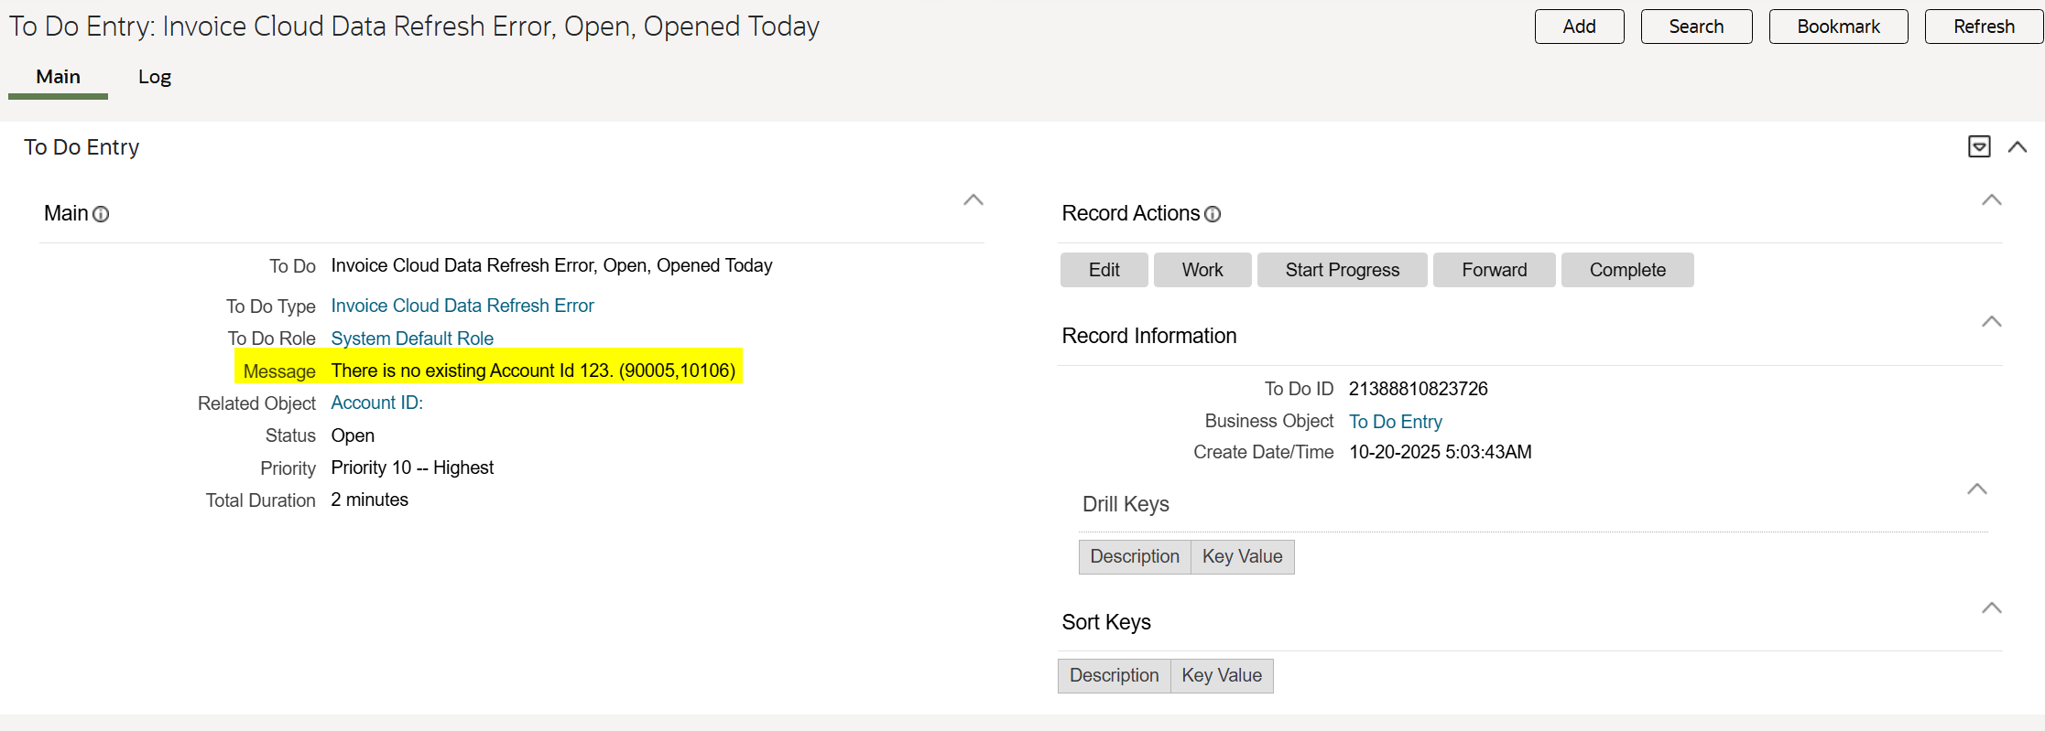
To Do Entry created.

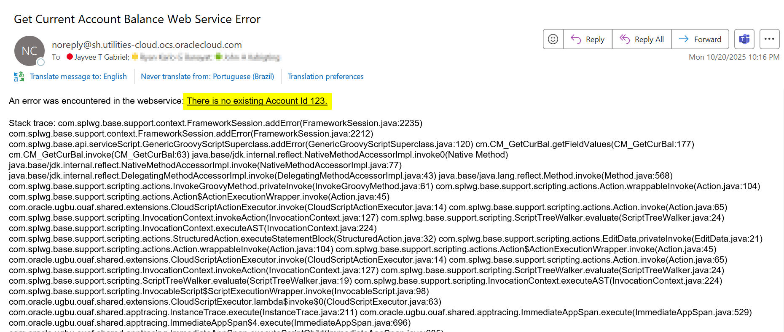
Email is sent.

CONDITION 2 – Feature Configuration is not configured.

Configuration Data
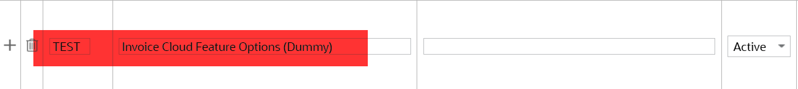
A dummy feature type is created for this scenario, but no Feature Configuration is configured.

Test Data
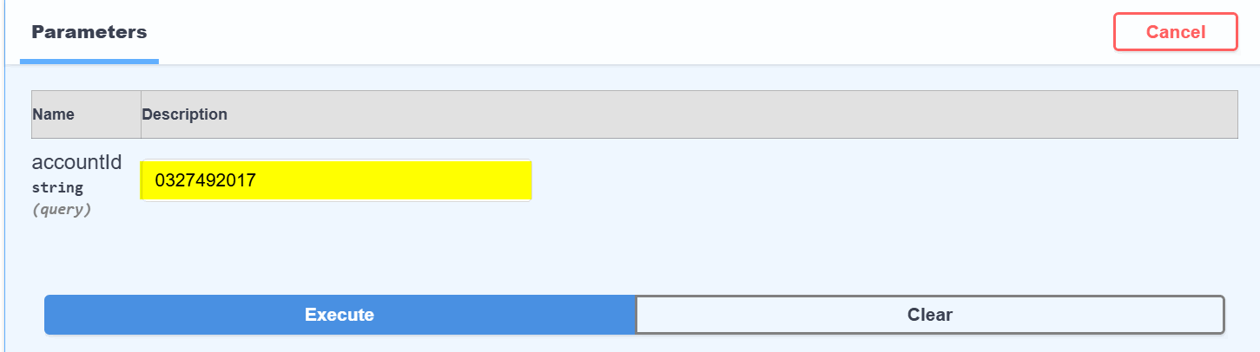

“0327492017” is inputted as accountId.

Result
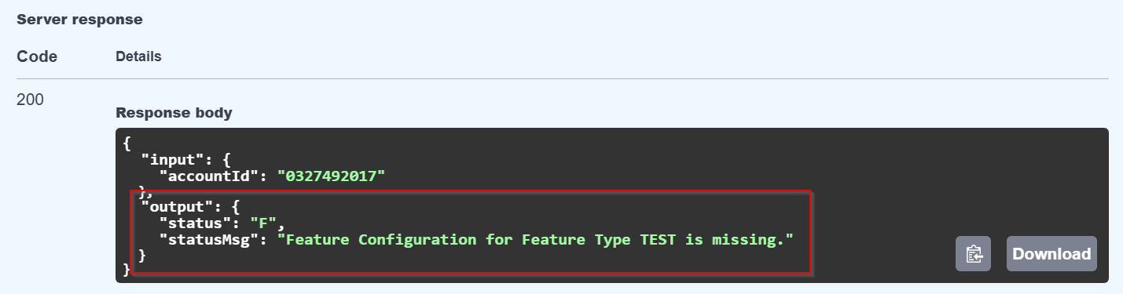
Status – F
Status Message - Feature Configuration for Feature Type TEST is missing.
No To Do Entry created.

CONDITION 3 – Data Refresh To Do Type is not configured in Feature Configuration.

Configuration Data
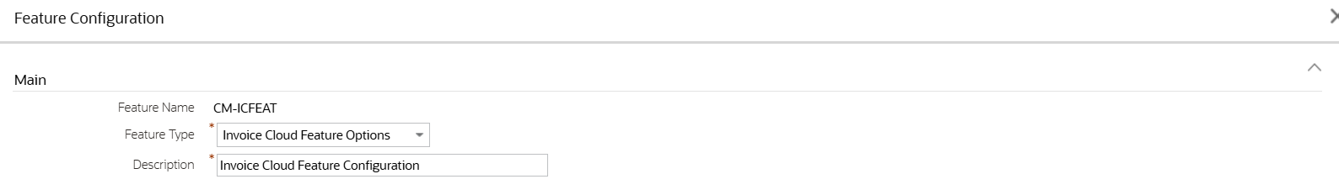

The highlighted option will be removed for this scenario.

Test Data

“0327492017” is inputted as accountId.

Result
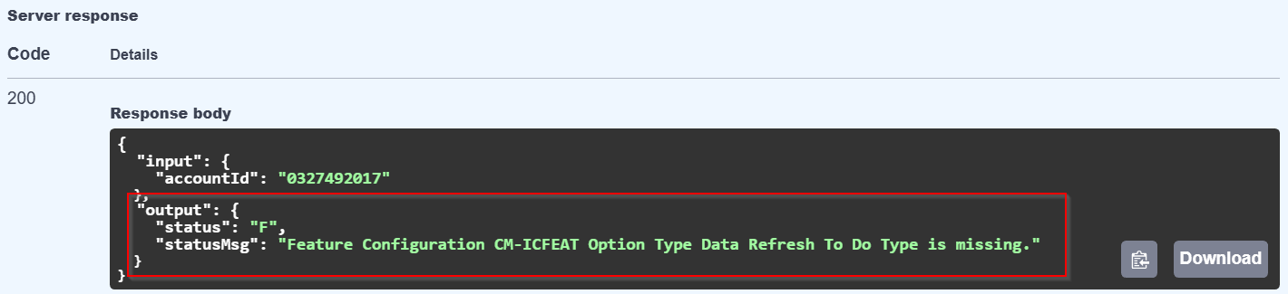
Status – F
Status Message - Feature Configuration CM-ICFEAT Option Type Data Refresh To Do Type is missing.
No To Do Entry created.

Email is sent.
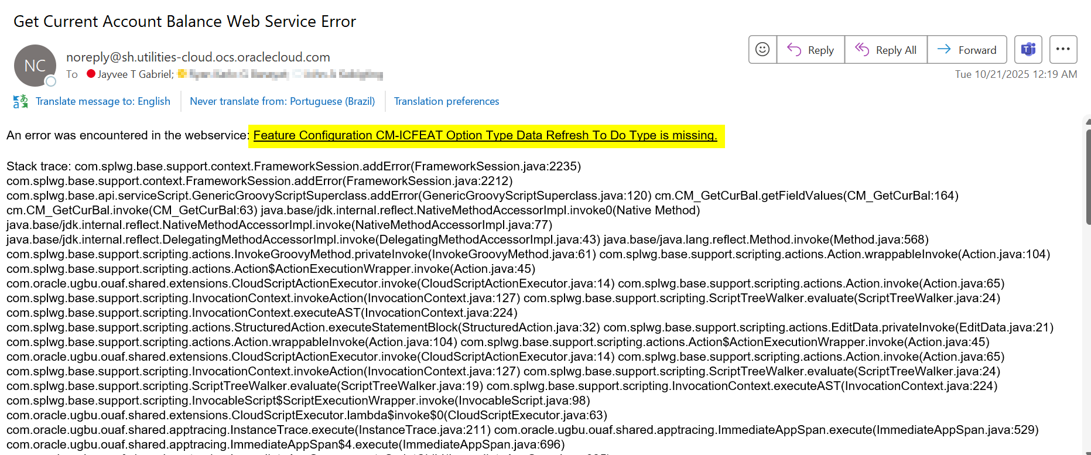

CONDITION 4 – Data Refresh To Do Type from the Feature Configuration is invalid.

Configuration Data

“CM-TEST” To Do Type is not existing in the system.

Test Data

“0327492017” is inputted as accountId.

Result
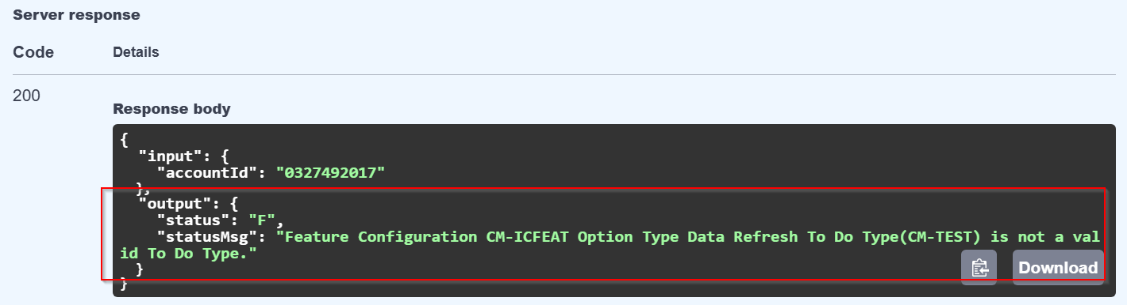

Status – F
Status Message - Feature Configuration CM-ICFEAT Option Type Data Refresh To Do Type (TEST) is not a valid To Do Type.
No To Do Entry created.
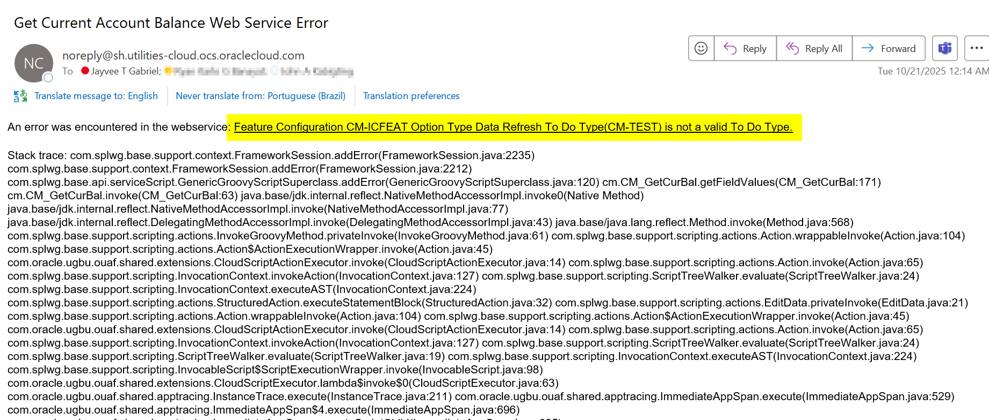
Email is sent.

CONDITION 5 – Account ID is valid.

Configuration Data

Test Data

“0327492017” is inputted as accountId.

Result
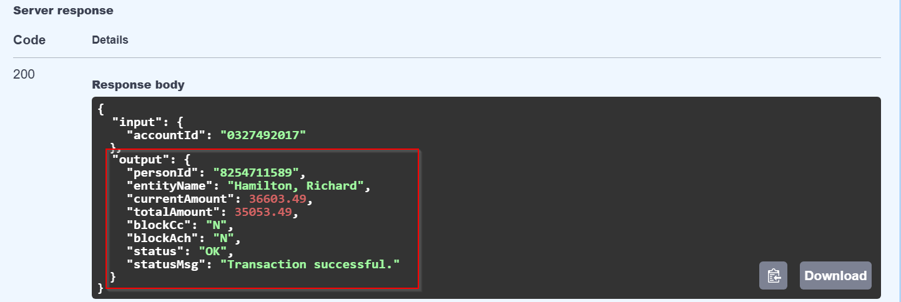

Status – OK
Status Message – Transaction Successful.
No To Do Entry created.
All output fields populated.

Open Issues
# | Issue Description | Resolved?  (Y/N) | Date Retested  PASS/FAIL
N/A | N/A | N/A | N/A

